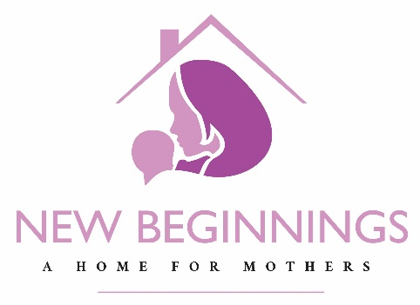

Heart Campaign
Update
April 3, 2023

Thank you for patiently waiting to receive an update on the Heart Campaign for New Beginnings - A Home for Mothers. As some of you might know, because of increasing inflation, construction costs keep rising. Meanwhile, fundraising is proceeding well but not as quickly as we would like. We therefore have come up with a plan.

As we are committed to reaching more mothers sooner than later, our board of directors approved phasing the project. The new goal is to raise approximately $3.2 million in addition to what we have raised so far. When we reach that intermediate goal we plan to break ground in late spring 2024. We have filed the one-year extension request with the Milwaukee Board of Zoning Approval in keeping with this modified plan.

Phase 1 of the building will include a finished 3rd floor along with all emergency corridors and the minimum necessary excavation and landscaping. This will enable us to take 6 residents and their children. We look to finish the other floors, the garages, and the rest of the excavating and landscaping as funds become available.

The property came with a small ranch home in very poor condition. We met with representatives of the Milwaukee Fire Department Academy and have agreed to donate that home for their training purposes. From April into June the training academy will bring new recruits to learn safety and fire containment skills. We have asked, upon conclusion of their training exercises, if they would then burn the place down and save us some demolition costs. Our request is being considered.

In short, we are making progress and adjusting to rapidly changing circumstances. Please do what you can to spread the word. We would be very happy to visit and talk about the Heart Campaign to all who are interested. Together, by the grace of God and according to his timing, we will get this project done.

Thank you and may God bless you as he blesses others through you.

Serving God, mothers, and their babies,

Mrs. Madison Schulz, Interim Ex. Director Mrs. Brittany Jahns, Donor Relations Associate
madisons@homeformothers.com brittanyj@christianliferesources.com

